A

PROJECT REPORT

ON

**A SHORT RANGE RADAR SYSTEM USING 8051 MICROCONTROLLER**

**SUBMITTED IN PARTIAL FULFILMENT OF THE REQUIREMENT FOR THE TE EMPLOYABILITY SKILL AND MINI PROJECT**

**BACHELOR OF ENGINEERING**

In

**ELECTRONICS AND TELECOMMUNICATION ENGINEERING**

By

**Atul B. Dharne Exam. No: T150433013**

**Nikhil S. Sonje Exam. No: T150433062**

**Sanket S. Mallawat Exam. No: T150433034**

Under the Guidance of

**Prof. V. M. SARDESHMUKH**



**Sinhgad Institutes**

Submitted to

**DEPARTMENT OF ELECTRONICS AND TELECOMMUNICATIONENGINEERING**

**STES’S SINHGAD ACADEMY OF ENGINEERING,**

**PUNE-411048** **2020-2021**



**CERTIFICATE**

**This is to certify that the project report entitled**

**A SHORT RANGE RADAR SYSTEM USING8051MICROCONROLLER**

**Submitted By**

**Atul B. Dharne Exam. No: T150433013**

**Nikhil S. Sonje Exam. No: T150433062**

**Sanket S. Mallawat Exam. No: T150433034**

**Is a bonafied work carried out by them under the supervision by Prof. V.M.Sardeshmukh and it is approved**

**for the partial fulfilment of the requirement of Savitribai Phule Pune University for the Employability Skill and Mini Project in the Third Year of Electronics and Telecommunication Engineering.**

**This project report has not been earlier submitted to any other institute or University for the award of any degree or diploma.**

**Prof.** **V.M.Sardeshmukh**

**Prof. K. M. Gaikwad**

**Dr. K. P. Pail**

**Project Guide**

**Place: Pune**

**Date:**

**H.O.D**

**Principal, SAOE, Pune**

**External Examiner**

**ACKNOWLEDGEMENT**

Any accomplishment requires the effort of many people and this work is no different. We found great pleasure in expressing our deep sense of gratitude towards all those who have made it possible for us to complete this project work.

We would first like to express the sincerest gratitude to our guide

Prof. V.M.Sardeshmukh without her encouragement and guidance it would not have been possible to successfully complete this project. Her influence on this project has been both tremendous and profound.

We would like to express a special thanks to Prof. V.M.Sardeshmukh, Project Coordinator, for her co-operation and help fullness.

It’s our pleasure to express the sense of gratitude towards Dr. K.M. Gaikwad, our vice Principal and head of department and Dr. K.P. Patil, our Principal, for his immeasurable encouragement and support.

Thank you all.

**Project Group Members:**

Atul B. Dharne Exam. No: T150433013

Nikhil S. Sonje Exam. No: T150433062

Sanket S. Mallawat Exam. No: T150433034

**Abstract**

The term radar was coined in 1940 by the United States Navy as an acronym for Radio Detection And Ranging. Radar is an object-detection system that uses radio waves to determine the range, angle, or velocity of objects. It can be used to detect aircraft, ships, spacecraft, guided missiles motor vehicles, weather information, and terrain information. A radar system consists of a transmitter producing electromagnetic waves in the radio or microwaves domain, a transmitting antenna, a receiving antenna. Radio waves (pulsed or continuous) from the transmitter reflect of the object and return to the receiver, giving information about the object's location and speed.

The main components in any Ultrasonic radar are the Ultrasonic Sensors. Ultrasonic sensors work on a principle similar to RADAR. Ultrasonic sensors generate high frequency sound waves and evaluate the echo which is received back by the sensor. Sensors calculate the time interval between sending the signal and receiving the echo to determine the distance to an object.

We come across situations where we need to keep a watch over prohibited areas to avoid trespassing. Now keeping human labour for this purpose is costly and also not reliable for keeping a watch over an area 24×7. So for this purpose an ultrasonic radar project for unauthorized human / animal or object detection system. The system can monitor an area of limited range and alerts authorities with a buzzer as an alarm. For this purpose we use a microcontroller circuit that is connected to an ultrasonic sensor mounted on a servo motor for monitoring.

The modern uses of radar are highly diverse, including air traffic control, radar astronomy, air-defence systems, antimissile systems ;marine radar start locate landmarks and other ships; aircraft anti-collision systems; ocean surveillance systems, outer space surveillance and rendezvous systems; meteorological precipitation monitoring; altimetry and flight control systems; guided missile target locating systems; and ground-penetrating radar for geological observations. High tech radar systems are associated with digital signal processing and are capable of extracting useful information from very high noise levels.

The Microcontroller based project requires a ultrasonic sensor, the sensor released the waves which we want to measure the distance of a object. The microcontrollers can be programmed using C and C++ languages. When a code is written in Keil software and apply in the microcontroller , System have lot of applications in the present day scenario, so we have decided to do a small project on them

**Table of Contents**

|  |  |  |
| --- | --- | --- |
| Acknowledgement | | III |
| Abstract | | IV |
| Table of Contents | | VI |
| List of Figures | | VII |
|  | |  |
| **Chapter 1** | **Introduction** | 8 |
| 1.1 | Introduction | 8 |
| 1.2 | Motivation | 9 |
| 1.3 | Problem Statement | 10 |
| 1.4 | Objectives of the proposed work | 10 |
|  |  |  |
| **Chapter 2** | **Literature Review** | 11 |
| 2.1 | Description | 11 |
| 2.2 | Overview Of Literature Survey | 12 |
|  |  |  |
| **Chapter 3** | **Project Description( Design, Theory and Component Details)** | 13 |
| 3.1 | General Explanation | 13 |
| 3.2 | Block Diagram | 13 |
| 3.3 | Procedure | 18 |
|  |  |  |
| **Chapter 4** | **Results** | 20 |
| 4.1 | Simulation Diagram: | 20 |
| 4.2 | PCB layout & 3D View | 21-22 |
| 4.3 | Simulation Result | 29-30 |
| 4.4 | Application | 31 |
|  | | |
| **References** | | 32 |

**List of Figures**

**Figure Chapter 3 Page**

3.2 Block Diagram of SRS System 13

3.2.1 Microcontroller 14

3.2.2 Ultrasonic Sensor 15

3.2.3 Working Principle Of Ultrasonic Sensor 16

3.2.4 Servo Motor 16

3.2.5 Buzzer 17

3.2.6 LCD Display 18

**Chapter 4**

4.1 Simulation 20

4.2 PCB Layout 21

4.2.1 3D View 22

4.3.1 Simulation Result A 31

4.3.2 Simulation Result B 32

**CHAPTER 1 – Introduction**

**1.1 Introduction :**

Radar is a long-range object detection system that uses radio waves to Established certain parameters of an object like its range, speed and position. The project is based on Sonar technology as I will be using an Ultrasonic Sensor to determine the presence of any object in a particular range. Rader is an object detection system. It uses Microwaves to determine the range, altitude, direction, or speed of objects. The radar can transmit radio waves or microwaves which bounce off any object in their path. So, we can easily determine any object in the radar range.

Radar is a contraction of the words Radio Detection And Ranging. Radar is an electromagnetic system for the detection and location of objects. It operates by transmitting a particular type of waveform, a pulse-modulated sine wave for example, and detects the nature of the echo signal. Radar can see through conditions such as darkness, haze, fog, rain, and snow which is not possible for human vision. In addition, radar has the advantage that it can measure the distance or range to the object. An elementary form of radar consists of a transmitting antenna emitting electromagnetic Radiation generated by an oscillator of some sort, a receiving antenna, and a signal receiver

A portion of the transmitted signal is intercepted by a reflecting object (target) and is reradiated in all directions. The receiving antenna collects the returned signal and delivers it to a receiver, where it is processed to detect the presence of the target and to extract its location and relative velocity. The distance to the target is determined by measuring the time taken for the Radar signal to travel to the target and back. The direction, or angular position, of the target is determined from the direction of arrival of the reflected wave front. The usual method of measuring the direction of arrival is with narrow antenna beams.

**Principle of Ultrasonic Rangefinder**

Generally, the distance can be measured using pulse echo method. The ultrasonic module transmits a signal to the object, then receives echo signal from the object and produces output signal whose time period is proportional to the distance of the object. The mechanism of the ultrasonic sensor is similar to the RADAR (Radio Detection and Ranging). This circuit calculates the distance of the object based on the speed of the sound wave at normal temperature and displays the distance on LCD.

**How Ultrasonic Radar System Works Using 8051 ?**

1. The HC-SR04 module has ultrasonic transmitter, receiver and control circuit on a single board.

2. When a pulse of 10sec or more is given to the Trig pin, 8 pulses of 40 kHz are generated. After this, the Echo pin is made high by the control circuit in the module.

3. Echo pin remains high till it gets echo signal of the transmitted pulses back.

4. The time for which the echo pin remains high, i.e. the width of the Echo pin gives the time taken for generated ultrasonic sound to travel towards the object and return.

5. Using this time and the speed of sound in air, we can measure the distance of the object using a simple formula for distance using speed and time.

**To Measure Distance:**

1. Object Distance (in cm) = (Sound Velocity * Time)/2,

Where, Sound Velocity = 34300 (in cm per second)

2. Here, oscillator frequency of AT89C51 (8051) is 11.0592 MHz, then timer frequency of

8051 will be 921.6 kHz.

3. So, Time required to execute 1 instruction is 1.085 us.

4. So, timer gets incremented after 1.085 us time elapse.

5. Hence, Distance= 34300 _ Timer Count _ 1:085 _ 10􀀀62(3.1)=Timer Count 54

**1.2 MOTIVATION**

We come across situations where we need to keep a watch over prohibited areas to avoid trespassing. Now keeping human labour for this purpose is costly and also not reliable for keeping a watch over an area 24×7. So for this purpose an ultrasonic radar project for unauthorized human / animal or object detection system. The system can monitor an area of limited range and alerts authorities with a buzzer as an alarm. For this purpose we use a microcontroller circuit that is connected to an ultrasonic sensor mounted on a servo motor for monitoring.

We also interface a buzzer and LCD screen for monitoring the detection status. The radar keeps monitoring the environment checking the ultrasonic sensor echo. As soon as an object is detected the data of detection is processed and sent to authorities with an alert of where exactly the object was detected. Thus ultrasonic radar proves to be a very useful system for 24×7 monitoring of a particular area/region. It can also work in any adverse conditions. It has higher sensing distance. Ultrasonic sensors can easily interface with Microcontroller or any type of controller. These sensors are easy to use, not dangerous during operation for nearby objects, person, equipment.

**1.3 PROBLEM STATEMENT**

To Create a Short Range Radar system using 8051 Microcontroller to used for target detection, target recognition. When the airplanes were invented so there is need of an instrument that could detect their location and time. So there is need of a system that could detect the aircrafts in air.

So to overcome this problem the scientists invented the “Radar System”, and our whole defence system, air-traffic, airport system is based on it.

* 1. **OBJECTIVES OF THE PROPOSED WORK :**

1. To simulate a circuit for the SRS system using proteus.
2. PCB fabricating, mounting and soldering.
3. Analysis of target detection, target recognition by SRS.

CHAPTER 2 – Literature Review

The ultrasonic sensor is used to map the distance of the things surrounding the point of reference, which is the place where the sensor is placed. This project is used for radar applications. The measured distance is plotted in planner graph i.e. distance v/s angle from servo motor, which give us the map containing the distance at which objects are placed near the sensor. The plot is actually two dimensional, because the distance measured is planner, which is the distance from sensor but not the altitude of the object from ground level. The graph is plotted 3 times, and in case if there is any change in the previous position, it will be indicated which means there is some disturbance or that there is new object before the sensor Arduino IDE sends data, which is distance from sensor and angle of the stepper motor to processing IDE, which is then plotted and we get the planar map of distance from sensor to the objects which are placed around It Test distance high level time x velocity of sound (340M/SI/2).

Distance measurement is the activity of obtaining and comparing in our real world. It is one of the important functions in science, engineering and astronomy to business activities. There are many types of distance measurement systems we use in our environment from normal rulers to Interferometer. In applications, basic concept of electronic distance measure system is adopted in many areas like aviation, navigation and many more. In aviation, direct feedback system is required for linear positioning and motion control application. One of the good examples for distance measurement in navigation is GPS system using satellites. So there is no doubt about the usefulness of distance measurement technology in our environment. Reviews of available literature of this project have been performed to ensure more understanding to construct ultrasonic distance meter. The areas that were focused are on behavior of ultrasound through journals, books, and internet. Although many different type of ranging systems available in market, there are only three major type of ranging systems used in technology which are Ultrasonic Ranging System.

|  |  |  |  |  |
| --- | --- | --- | --- | --- |
| Sr.No. | Year | Name of paper | Name of author | Review |
| 1. | June 2011 | Frequency-agile non-coherent ultrasound radar for collection of micro-Doppler signatures | Balleri, K. Woodbridge | Here, Ultrasonic Sensors is used to control the range and parameters and provides better control and accuracy . |
| 2. | May 2009 | Ultrasound System Considerations and their Impact on Front-End Components | Brunner Eberhard and Analog Devices | This work present an event based control technique and its combination with Synthetic Array Radar (SAR) ultra sound and is really very similar to a radar or sonar system |
| 3. | June 2018 | Space and frequency diversity for moving personnel spectrogram estimation | P. Sammartino, J. Fortuny-Guash, | The frequency diverse array (FDA) and conventional phased-array (CPA) radar use to complete wide-area search and detection |
| 4. | June 2013 | Radar System Using Arduino And Ultrasonic Sensors | Shreyes Mehta, Shashank Tiwari | In this system they reduces power consumption and connect programmer to wide range by using Arduino |

Chapter 3 Project Description

**3.1 General Explanation**

Ultrasonic RADAR module is interfaced with the serial port of microcontroller. The Transmitted wave being reflected from the object and is received by the ultrasonic Receiver sensor and the output of which is fed to microcontroller. Microcontroller is the heart of the proposed embedded system which process the data from sensor and display the data on 16*2 LCD display.

**3.2 BLOCK DIAGRAM**

LCD Display

Microcontroller

Ultrasonic Sensor

Buzzer

Servo Motor Servo Motor

Motor

LED

Power Supply

**Fig.3.2 Shows the block diagram of SRS System**

The block diagram consist of 5 major parts.

1. 8051 Microcontroller

2. Ultrasonic Sensor

3. Buzzer.

4. Servo Motor

5. LCD Display.

**MICROCONTROLLER**

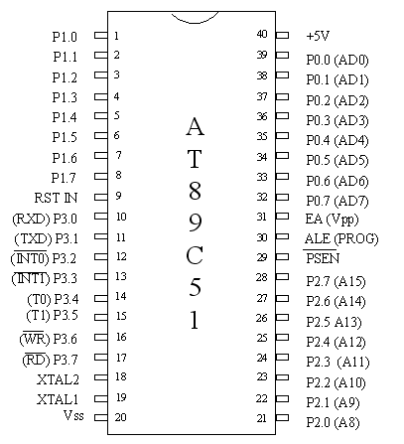

**Fig 3.2.1 Microcontroller**

AT89S51 is a low-power, high-performance CMOS 8-bit microcontroller with 4K bytes of In-System Programmable Flash memory. The device is manufactured using Atmel’s high density nonvolatile memory technology and is compatible with the industry standard 80C51 instruction set and pin out.

• Model 78E052D(NUVOTON)

• Operating Vg. 5V

• 8 Bit Microcontroller

• 256 Bytes RAM

• 8 KB ROM

• Frequency 12MHz.

**Ultrasonic Sensor**

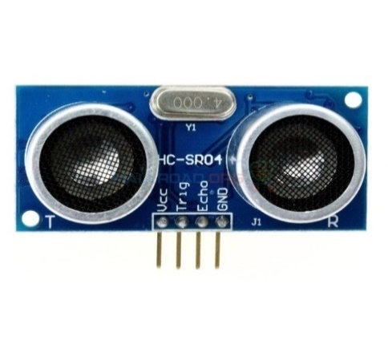

**Fig 3.2.2 Ultrasonic sensor**

* Ultrasonic sensor is mainly used to determine the distance of the target object.
* Transmitter and receiver are two main parts of the sensor where former converts an electrical signal to ultrasonic waves while later converts that ultrasonic signals back to electrical signals.
* Ultrasonic ranging module HC - SR04 provides 2cm - 400cm non-contact measurement function, the ranging accuracy can reach to 3mm. and control the circuit within measuring angle of 15 degrees.

**The Basic Principle Of Ultrasonic Sensor**

**(**1) Using IO trigger for at least 10us high-level signal,

(2) The Module automatically sends eight 40 kHz and detect whether there is a

pulse signal back.

(3) IF the signal back, through high level, time of high output IO duration isthe time

from sending ultrasonic to returning.

Test distance = (high level time × velocity of sound (340M/S) / 2.

**Wire connecting directly as following:**

5V Supply

Trigger Pulse Input

Echo Pulse Output

0V Ground

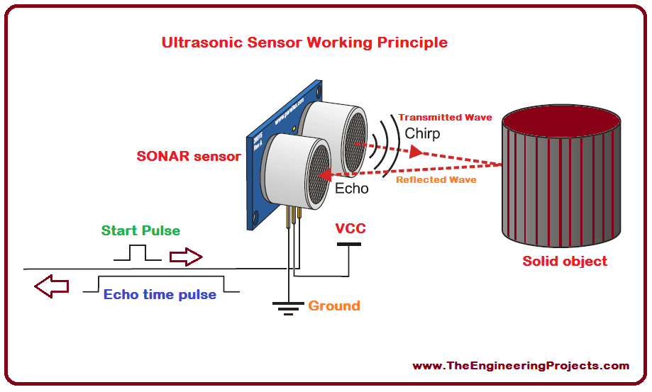

**Fig 3.2.3 Working Principle Of Ultrasonic Sensor**

**Servo motor**

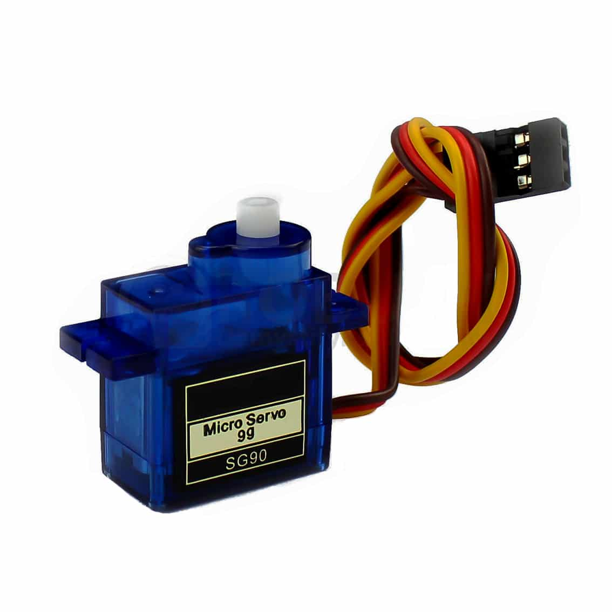

**Fig 3.2.4 Servo Motor**

Servomotor is a servomechanism. It is a closed-loop servomechanism that uses position feedback to control its motion and final position. The input to its control is some signal, either analogue or digital, representing the position commanded for the output shaft. The motor is paired with some type of encoder to provide position and speed feedback.Tiny and light weight with high output power. The servo motor can rotate approximately 180 degrees (90 in each direction), and work

just like the standard kinds but smaller. You can use any servo code, hardware or library to control these servo motor

**Specifications**

Weight: 9 g

Dimension: 22.2 x 11.8 x 31 mm approx.

Stall torque: 1.8 kg f cm

Operating speed: 0.1 s/60 degree

Operating voltage: 4.8 V (~5V)

Temperature range: 0 ºC – 55 ºC.

**BUZZER:**

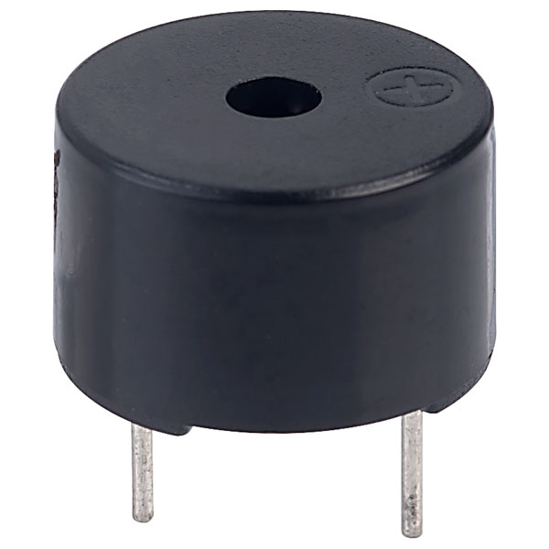

**Fig 3.2.5 Buzzer**

The buzzer consists of an outside case with two pins to attach it to power and ground. ... When current is applied to the buzzer it causes the ceramic disk to contract or expand. Changing the This then causes the surrounding disc to vibrate. That's the sound that you hear.

• A buzzer or beeper is an audio signaling device.

• Operating Vg. 5V

• No. of pins 2

• VCC and GND

**LCD DISPLAY**

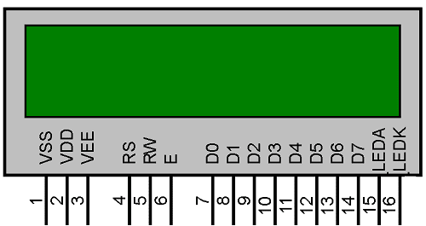

**Fig.3.2.6 LCD Display**

• 16*2 Liquid Crystal Display [LCD]

• Operating Vg. 5V

• No. of Pins 16 Pins

• VCC, GND, RS, EN, R/Ŵ, 8 Data Pins, 2 back light LED & POT.

**3.3Procedure**

1. Initially burn the program to the microcontroller

2. Now give the connections as per the circuit diagram

3. While giving the connections make sure that Vcc of ultrasonic module is connected to 5V DC

4. Switch on the board supply

5. Place the obstacle in front of the ultrasonic module, now you can observe the distance on LCD.

6. Switch off the board supply

The technique of distance measurement using ultrasonic in air include continuous wave & pulse echo technique. In the pulse echo method, a burst of pulses is sent through the transmission medium & is reflected by an object kept at special distance. The time taken for the pulse to propagate from transmitter to receiver is proportional to the distance of object. For contact less measurement of distance, the device has to rely on the target to reflect the pulse back to itself. The target needs to have a proper orientation that is it needs to be perpendicular to the direction of propagation of the pulses. The amplitude of the received signal gets significantly attenuated and is a function of nature of the medium and the distance between the transmitter and target. The pulse echo or time-of-flight method of range measurement is subject to high levels of signal attenuation when used in an air medium, thus limiting its distance range.

The basic objective of our design is to ascertain the distance position and speed of the obstacle set at some distance from the sensor. Ultrasonic sensor sends the ultrasonic wave in various ways by rotating with help of servo motors. This wave goes in air and gets reflected back subsequent to striking some object. This wave is again detected by the sensor and its qualities is analyzed and output is shown in screen indicating parameters, for example, distance and position of object.

• Output of all of this working is shown in the software called processing, it will display the input/output and the range of the object. Implementations of the sensors are done in such a way that ultra-sonic sensor is attached on top of the servo motor because it have to detect

the object and its distance. Arduino (micro-controller) will control the ultra-sonic sensor and servo motor and also powered will be given to both of them through micro-controller.

• When any obstacle/object is detected by the ultrasonic sensor the data is immediately processed by the controller and is fed to the IDE which shows it on the display screen. Here the process ends with an estimated distance of the object from the system with the angle at which it is placed.

**CHAPTER 4 – Result**

**4.1Simulation Diagram:**

Here Is The Simulation Diagram Of Our Project. Where all the components are connected with the At89c51 microcontroller and the distance will displayed at the Lcd.

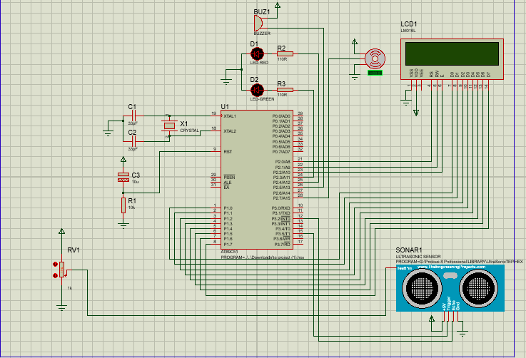

**Fig 4.1 Simulation**

**4.2 PCB layout & 3D View**

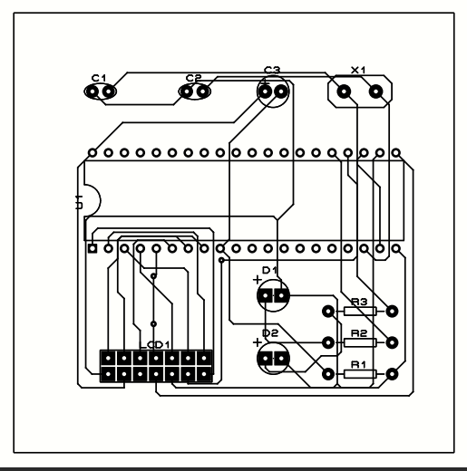

**Fig 4.2 PCB layout**

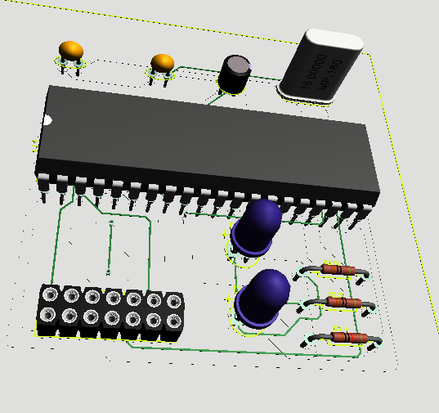

**Fig 4.2.1 3D View**

**4.3 Code**

**#include<reg51.h> //Header file inclusion for 8051**

**#include<intrins.h> // for using nop() function**

**void delay(unsigned int rtime);**

**void lcdcmd(unsigned char DATA);**

**void initialize(void);**

**void lcddat(unsigned char DATA);**

**void display_lcd(unsigned char location, unsigned char *d);**

**void send_pulse(void);**

**void lcd_number(int val);**

**void get_range(void);**

**#define LCDdata P1 //Declaring LCDdata**

**#define buz P1**

**sbit trig=P3^5;//timer 1**

**sbit echo=P3^2;//INTR 0**

**sbit led1 = P2^3;**

**sbit led2 = P2^4;**

**sbit buzz = P2^5;**

**sbit LCDrs = P2^0; //The Register select Pin**

**sbit LCDrw = P2^1; //The Read/Write Pin**

**sbit LCDen = P2^2; //The Enable Pin**

**void delay(unsigned int rtime)**

**{**

**unsigned int r,s;**

**for(r=0;r<rtime;r++)**

**for(s=0;s<1275;s++);**

**}**

**void lcdcmd(unsigned char DATA)**

**{**

**LCDrs=0;**

**LCDrw=0;**

**LCDen=1; //Strobe the enable pin**

**LCDdata = DATA; //Put the value on the pins**

**LCDrs=0;**

**LCDrw=0;**

**LCDen=0;**

**}**

**void initialize(void)**

**{**

**lcdcmd(0x30); //1 line and 5x7 matrix**

**delay(1);**

**lcdcmd(0x38); //2 line and 5x7 matrix**

**delay(1);**

**lcdcmd(0x0c); //Display on, cursor off**

**delay(1);**

**lcdcmd(0x01); //Clear display Screen**

**delay(1);**

**lcdcmd(0x06); //shift cursor to right**

**delay(1);**

**}**

**void lcddat(unsigned char DATA)**

**{**

**LCDrs = 1;**

**LCDrw = 0;**

**LCDen = 1; //Strobe the enable pin**

**LCDdata = DATA; //Put the value on the pins**

**LCDrs = 1;**

**LCDrw = 0;**

**LCDen = 0;**

**}**

**void display_lcd(unsigned char location, unsigned char *d)**

**{**

**lcdcmd(0x00 | location);**

**delay(1); //10mS delay generation**

**while(*d)**

**{**

**lcddat(*d++);**

**delay(1); //10mS delay generation**

**}**

**}**

**void send_pulse(void) //to generate 10 microseconds delay**

**{**

**TH0=0x00;**

**TL0=0x00;**

**trig=0;**

**trig=1;**

**nop();nop();nop();nop();nop(); //each nop() generates 1u sec of delay**

**nop();nop();nop();nop();nop();**

**trig=0;**

**}**

**void lcd_number(int val) // Function to display number**

**{**

**int i=3;**

**char str[7]={" 00 CM"};**

**while(val)**

**{**

**str[i]=0x30 | val%10;**

**val=val/10;**

**i--;**

**}**

**display_lcd(0xC5,str);**

**}**

**void get_range(void)**

**{**

**int range=0;**

**int timerval;**

**send_pulse();**

**while(INT0==0);**

**while(INT0==1);**

**timerval = TH0;**

**timerval = (timerval << 8) | TL0;**

**TH0=0xFF;**

**TL0=0xFF;**

**if(timerval<35000) //Makimum 38000us work at higher levels**

**range=timerval/59;**

**else**

**range = 0;**

**lcd_number(range);**

**if (range <= 500 && range >= 100) {**

**led1=1;**

**led2=0;**

**buzz=0x01;**

**} else {**

**led2=1;**

**led1=0;**

**buzz=0x00;**

**}**

**}**

**void main(void)**

**{**

**led1=0;**

**led2=0;**

**initialize(); //initilaze LCD**

**display_lcd(0x80," WELCOME TO SRR ");**

**delay(500);**

**display_lcd(0x80," SYSTEM ");**

**delay(500);**

**display_lcd(0x80," GET START ");**

**delay(200);**

**//unsigned char string[]={"distance"};**

**initialize(); //initilaze LCD**

**display_lcd(0x80," OBSTACLE AT "); //Display character String from location specified**

**TMOD=0x09; //timer0 in 16 bit mode with gate enable**

**TR0=1; //timer run enabled**

**TH0=0x00;**

**TL0=0x00;**

**echo = 1; //setting pin P3.2 as input**

**while(1)**

**{**

**get_range();**

**delay(2);**

**}**

**}**

**4.3 Simulation Result**

When we start our SRR System we see the range of obstacle on the Lcd Display. When the obstacle where detected under the range of 100cm The Red led was starts glowing and also the Bipping sound of buzzer occurs and we get alert about the obstacle movement is very closer to us. You can see the result in below diagram.

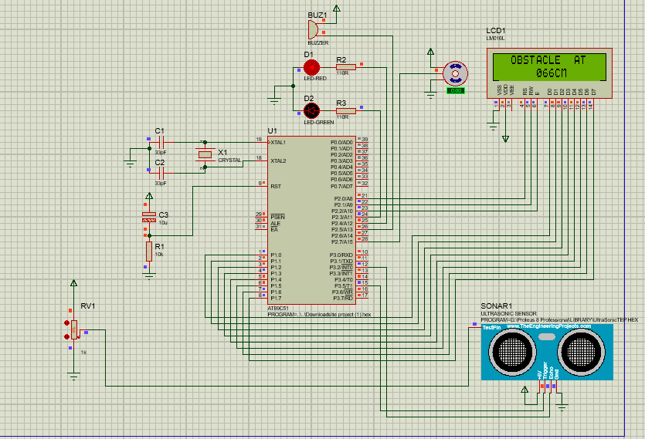

**Fig 4.3.1 Simulation Result A**

And If the range of Obstacle was beyond 100 cm The Green Led will glow and the distance will be displayed on Lcd Screen and we get the exact location of the obstacle.

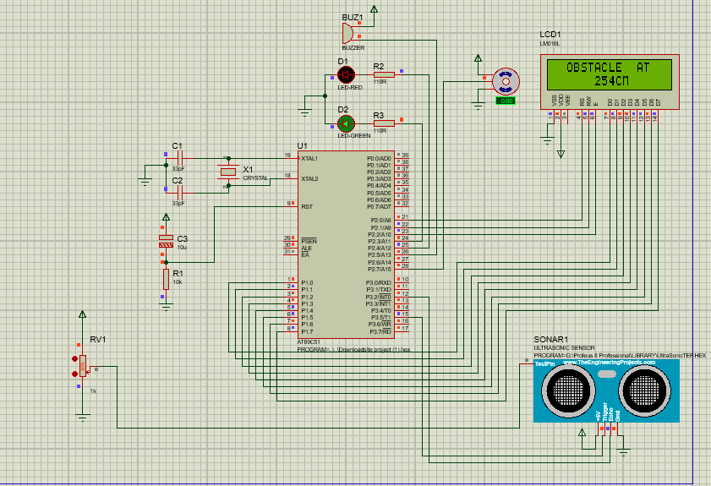

**Fig 4.3.2 Simulation Result B**

**4.4 Application**

* Radar is an electromagnetic system for the detection and location of target objects such as aircraft, ships, spacecraft, vehicles, people, and the natural environment which can reflect a signal back.
* In air defence system it is used for target detection, target recognition and Identifying enemy location in map.
* RADAR speed meters are used by traffic police for enforcing speed limit.
* It uses electromagnetic radio waves to determine the angle, range, or velocity of objects.
* The modern radar system is more advanced and the uses of radar are highly diverse. Such as Air traffic control, Air-defence system, radar Astronomy, Antimissile system, Ocean Surveillance system, outer space surveillance and many more.

**FUTURE SCOPE:**

1) A GSM can be used to send SMS to concerned person about detected object, distance.

2) A camera can also be used to view the live video.

3) Instead of providing a different voltage source for operating ultrasonic

sensor and servo motor, we have used supply from the micro-controller.

By this way we reduced the cost of voltage supplies.

**CONCLUSION:**

In This Project, Interfacing of Ultrasonic module HC-SR04 with 8051 Microcontroller using Keil software was performed successfully and using the mechanism of the ultrasonic sensor the object distance up to 4 meters was measured and this system (HC SR04 ultrasonic sensor)was not able to measure longer distances. Hence, for more range, we can try replacing the sensor module.

Radar is normally used to determine velocity, range, and position of an object. In this technical project, we read the distance and angles of detected objects in order to convert these data into visual information. The performance of our project is so good. It works smoothly to detect objects within the designed range. The screen shows the information clearly with enough delay for the user to read it. This project could be helpful for object avoidance/ detection applications. This project could easily be extended and could be used in any systems may need it.

**REFERENCES:**

1. Frequency-agile non-coherent ultrasound radar for collection of micro-Doppler signatures, By: Balleri, K. Woodbridge, June 2011
2. Ultrasound System Considerations and their Impact on Front-End Components, By: Brunner Eberhard, May 2009
3. Space and frequency diversity for moving personnel spectrogram estimation By: P. Sammartino, J. Fortuny-Guash, June 2018
4. Radar System Using Arduino And Ultrasonic Sensors By Shreyes Mehta, Shashank Tiwari, June 2013

THANK YOU